

A UNIFIED DASHBOARD APPROACH FOR SMARTHOME AUTOMATION AND MONITORING

A PROJECT REPORT
Submitted by

NANDHINI S (927623BAD066)

NIVETHA R T (927623BAD071)

PRITHISHA S (927623BAD084) RITHIKA G (927623BAD090)

in partial fulfillment for the award of the degree of

BACHELOR OF TECHNOLOGY

in

ARTIFICIAL INTELLIGENCE AND DATA SCIENCE

M. KUMARASAMY COLLEGE OF ENGINEERING ANNA UNIVERSITY : : CHENNAI 600 025
APRIL 2025

A UNIFIED DASHBOARD APPROACH FOR SMARTHOME AUTOMATION AND MONITORING

A PROJECT REPORT
Submitted by

NANDHINI S (927623BAD066)

NIVETHA R T (927623BAD071)

PRITHISHA S (927623BAD084) RITHIKA G (927623BAD090)

in partial fulfillment for the award of the degree of

BACHELOR OF TECHNOLOGY

in

ARTIFICIAL INTELLIGENCE AND DATA SCIENCE

M. KUMARASAMY COLLEGE OF ENGINEERING ANNA UNIVERSITY : : CHENNAI 600 025
APRIL 2025

M. KUMARASAMY COLLEGE OF ENGINEERING
(Autonomous Institution affiliated to Anna University, Chennai)
KARUR – 639 113
BONAFIDE CERTIFICATE

Certified that this project report “A UNIFIED DASHBOARD APPROACH FOR SMARTHOME AUTOMATION AND MONITORING” is the bonafide work of NANDHINI S (927623BAD066), NIVETHA R T (927623BAD071), PRITHISHA S (927623BAD084), RITHIKA G (927623BAD090) who carried out the project work during the academic year 2025-2026 under my supervision. Certified further, that to the best of my knowledge the work reported herein does not form part of another project report or dissertation on the basis of which a degree or award was conferred on an earlier occasion on this or any other candidate.

Signature | Signature
Dr.K.V.NITHYA M.Sc.,M.Phil.,Ph.D., | Dr.A.Selvi, M.E., Ph.D.,
SUPERVISOR, | HEAD OF THE DEPARTMENT,
Department of Artificial Intelligence and | ASSISTANT PROFESSOR,
Data Science, | Department of Artificial Intelligence,
M.Kumarasamy College of Engineering, | M.Kumarasamy College of Engineering,
Thalavapalayam, Karur-639113. | Thalavapalayam, Karur-639113.

This Project report has been submitted for the Project Work - End Semester viva voce Examination held on

INTERNAL EXAMINER EXTERNAL EXAMINER

DECLARATION
We affirm that the Project report titled “A UNIFIED DASHBOARD APPROACH FOR SMARTHOME AUTOMATION AND MONITORING” being submitted in partial fulfillment for the award of Bachelor of Technology in Artificial Intelligence and Data Science is the original work carried out by us. It has not formed the part of any other project report or dissertation on the basis of which a degree or award was conferred on an earlier occasion on this or any other candidate.

 |  | SIGNATURE
NANDHINI S | (927623BAD066)
NIVETHA R T | (927623BAD071)
PRITHISHA S | (92762BAD084)
RITHIKA G | (927623BAD090)

ACKNOWLEDGEMENT
We gratefully remember our beloved Founder Chairman, (Late) Thiru. M. Kumarasamy, whose vision and legacy laid the foundation for our education and inspired us to successfully complete this project.
We extend our sincere thanks to Dr. K. Ramakrishnan, Chairman, and Mr. K. R. Charun Kumar, Joint Secretary, for providing excellent infrastructure and continuous support throughout our academic journey.
We are privileged to extend our heartfelt thanks to our respected Principal, Dr. B. S. Murugan, B.Tech., M.Tech., Ph.D., for providing us with a conducive environment and constant encouragement to pursue this project work.
We sincerely thank Dr. A. Selvi, M.E., Ph.D., Assistant Professor and Head, Department of Artificial Intelligence, for her continuous support, valuable guidance, and motivation throughout the course of this project.
Our special thanks and deep sense of appreciation go to our Project Supervisor, Dr. K.V.Nithya,Ph.D., Assistant Professor, Department of Artificial Intelligence and Data Science, for her exceptional guidance, continuous supervision, constructive suggestions, and unwavering support, all of which have been instrumental in the successful execution of this project.
We would also like to acknowledge Dr.K.V.Nithya,Ph.D., Assistant Professor, our Project Supervisor and Project Coordinator, for constant encouragement and coordination that contributed to the smooth progress and completion of our project work.
We gratefully thank all the faculty members of the Department of Artificial Intelligence and Data Science for their timely assistance, valuable insights, and constant support during various phases of the project.
Finally, we extend our profound gratitude to our parents and friends for their encouragement, moral support, and motivation, without which the successful completion of this project would not have been possible.

M.KUMARASAMY COLLEGE OF ENGINEERING DEPARTMENT OF ARTIFICIAL INTELLIGENCE AND DATA SCIENCE
Vision of the Institution

To emerge as a leader among the top institutions in the field of technical education

Mission of the Institution
Produce smart technocrats with empirical knowledge who cansurmount the global challenges
Create a diverse, fully-engaged, learner- centric campus environment to provide quality education to the students
Maintain mutually beneficial partnerships with our alumni, industry, and Professional associations

Vision of the Department
To produce competent, industry-relevant education and develop skillful research-oriented, technical, and innovative computer science professionals equipped with managerial abilities and strong human and social values.

Mission of the Department
M1: To impart technical knowledge through innovative teaching, research, and consultancy.
M2: To develop and promote student abilities that enable them to compete globally through excellence in education.
M3: To facilitate the development of strong academic–industry collaboration.
M4: To produce competent engineers with professional ethics, technical expertise, a spirit of innovation, and managerial skills.

Program Educational Objectives (PEOs)
- PEO1: To acquire the technical knowledge and proficiency needed for employment and higher education in contemporary areas of computer science or management studies.
- PEO2: To apply competencies in designing and developing innovative solutions for realworld problems.
- PEO3: To demonstrate leadership qualities with strong ethical standards and collaborate with industries for the socio-economic growth of the country.
Program Outcomes (POs)
- PO1: Engineering knowledge: Apply the knowledge of mathematics, science, engineering fundamentals, and specialized engineering concepts to solve complex engineering problems.
- PO2: Problem analysis: Identify, formulate, and analyze complex engineering problems by reviewing research literature and applying first principles of mathematics, natural sciences, and engineering sciences to reach valid conclusions.
- PO3: Design/development of solutions: Design solutions for complex engineering problems and develop system components or processes that meet specified needs while considering public health, safety, cultural, societal, and environmental aspects.
- PO4: Conduct investigations of complex problems: Use research-based knowledge and methods, including designing experiments, analyzing and interpreting data, and synthesizing information, to arrive at valid and reliable conclusions.
- PO5: Modern tool usage: Create, select, and apply modern techniques, tools, and IT resources including prediction and modeling tools—to complex engineering activities, with a clear understanding of their limitations.
- PO6: The engineer and society: Apply contextual knowledge to assess societal, health, safety, legal, and cultural issues, and understand the professional responsibilities relevant to engineering practice.
- PO7: Environment and sustainability: Understand the impact of engineering solutions on society and the environment and recognize the importance of sustainable development.
- PO8: Ethics: Apply ethical principles and commit to professional ethics, responsibilities, and norms of engineering practice.
- PO9: Individual and team work: Function effectively as an individual and as a member or leader diverse teams and multidisciplinary environments.
- PO10: Communication: Communicate effectively on complex engineering activities with the engineering community and society at large, including the ability to write clear reports, prepare proper documentation, make effective presentations, and give and receive clear instructions.
- PO11: Project management and finance: Demonstrate knowledge and understanding of engineering and management principles and apply them to one’s own work as a team member or leader to manage projects in multidisciplinary settings.
- PO12: Life-long learning: Recognize the need for continuous learning and possess the ability to engage independently in life-long learning in the context of technological advancements.
Program Specific Outcomes (PSOs)
- PSO1: Ability to apply analytical and business skills to provide sustainable and practical solutions for real-time applications by utilizing Machine Learning, the Internet of Things, and Data Analytics.
- PSO2: Ability to practice ethical and human values along with strong soft skills in compute science and business domains, enabling individuals to emerge as entrepreneurs who contribute to growth and development of society.

ABSTRACT

The rapid growth of Internet of Things (IoT) technologies has transformed residential and commercial environments into interconnected intelligent ecosystems. Despite this progress, users continue to face challenges in managing heterogeneous smart devices due to platform fragmentation, inconsistent communication standards, and limited interoperability. The proposed system provides a cohesive interface that supports real-time monitoring, remote access, device grouping, customizable automation routines, and status visualization. To ensure efficient communication, scalability, and secure data exchange, the architecture incorporates lightweight IoT communication protocols including MQTT, WebSocket. The dashboard’s modular design enables interoperability between multi-vendor devices while supporting future expansion. A functional prototype demonstrates significant improvements in energy efficiency, operational reliability, and user convenience through automated control and optimized resource utilization. The solution highlights the potential of unified IoT platforms in simplifying smart home management and contributes toward the development of adaptable, secure, and user-centric smart environments

Keywords: IoT, Smart Home Automation, Unified Dashboard, MQTT, WebSocket, Real-Time Monitoring, Device Interoperability, Automation Control.
ABSTRACT WITH PSOs AND PSOs MAPPING

ABSTRACT | POs MAPPED | PSOs MAPPED
The rapid growth of Internet of Things (IoT) technologies has transformed residential and commercial environments into interconnected intelligent ecosystems. Despite this progress, users continue to face challenges in managing heterogeneous smart devices due to platform fragmentation, inconsistent communication standards, and limited interoperability. The proposed system provides a cohesive interface that supports real-time monitoring, remote access, device grouping, customizable automation routines, and status visualization. To ensure efficient communication, scalability, and secure data exchange, the architecture incorporates lightweight IoT communication protocols including MQTT, WebSocket. The dashboard’s modular design enables interoperability between multi-vendor devices while supporting future expansion. A functional prototype demonstrates significant improvements in energy efficiency, operational reliability, and user convenience through automated control and optimized resource utilization.  Keywords: IoT, Smart Home Automation, Unified Dashboard. | PO2(3),  PO3(3),  PO6(2),  PO7(3),  PO9(3), | PSO1(3), PSO2(2)

NOTE: 1-LOW, 2-MEDIUM, 3-HIGH

SUPERVISOR HEAD OF THE DEPARTMENT

TABLE OF CONTENT

CHAPTER NO. TITLE PAGE NO.

ABSTRACT | VIII
LIST OF TABLES | XII
LIST OF FIGURES | XIII
LIST OF ABBREVIATIONS | XIV
1 INTRODUCTION | 1
- SMART HOME AUTOMATION OVERVIEW  - UNIFIED DASHBOARD DESIGN & DEVICE CONTROL  - REAL-TIME DATA MONITORING & COMMUNICATION PROTOCOLS | 1
- BACKEND SYSTEM, API INTEGRATION & SECURITY | 3
- CHALLENGES IN IMPLEMENTATION  - ADVANTAGES OF SMART HOME CONTROL DASHBOARD  - CENTRALIZED DEVICE CONTROL  - REAL-TIME AUTOMATION & MONITORING  - ENERGY SAVING & EFFICIENCY  - IMPROVED HOME SECURITY  - USER-FRIENDLY WEB & MOBILE ACCESS  - SCALABILITY FOR FUTURE DEVICES | 5  4  4  4  4  5  5
2 LITERATURE SURVEY | 7
3 EXISTING SYSTEM | 19
3.1 DISADVANTAGES | 20

4 PROBLEMS IDENTIFIED | 21
5 PROPOSED SYSTEM | 22
5.1 PROPOSED SYSTEM ARCHITECTURE | 23
5.1.1 INITIALIZATION STEP | 23
5.1.2 LOCAL NODE COMPONENTS | 24
5.1.3 LOCAL DEVICE OPERATIONS | 24
5.1.4 COMMAND SENDING | 24
5.1.5 AUTOMATION PROCESSING AT BACKEND | 24
5.1.6 GLOBAL STATUS UPDATE | 24
5.1.7 DEVICE DATA DISTRIBUTION | 24
5.1.8 ITERATRIVE PROCESS | 25
5.1.9 REAL WORLD APPLICATION CONTEXT | 25
6 SYSTEM REQUIREMENTS | 26
6.1 HARDWARE REQUIREMENTS | 26
6.2 SOFTWARE REQUIREMENTS | 26
7 SYSTEM IMPLEMENTATION | 27
7.1 LIST OF MODULES | 27
7.2 MODULES DESCRIPTION | 28
7.2.1 USER AUTHENTICATION &  PROFILE MANAGEMENT | 28
7.2.2 DASHBOARD & VISUALIZATION | 28
7.2.3 APPLIANCE CONTROL | 28
7.2.4 ENERGY MONITORING | 28
7.2.5 NOTIFICATION & ALERT | 29

7.3 DATASET DISCRIPTION | 29
7.3.1 DEVICE STATE | 29
7.3.2 SENSOR DATA | 29
7.3.3 ENERGY USAGE | 30
7.3.4 AUTOMATION LOG DATA | 30
7.3.5 USER ACTIVITY LOGS  7.3.6 SYSTEM NOTIFICATION  7.3.7 DEVICE HEALTH & STATUS MONITORING  7.3.7 AUTOMATION RECOMMENDATION | 30
8 SYSTEM TESTING | 32
8.1 UNIT TESTING | 32
8.2 INTEGRATION TESTING | 32
8.3 PERFORMANCE TESTING | 33
8.4 SECURITY TESTING | 33
8.5 USABILITY TESTING | 33
9 RESULT AND DISCUSSION | 34
10 CONCLUSION AND FUTURE ENHANCEMENT | 35
10.1 CONCLUSION | 35
10.1 FUTURE ENHANCEMENT | 35
APPENDIX 1 | 37
APPENDIX 2 | 42
REFERENCES | 45

LIST OF TABLES

TABLE  NO | TITLE | PAGE  NO
2.1 | SMART HOME CONTROL SYSTEMS | 15
2.2 | COMMUNICATION TECHNOLOGIES FOR SMART HOME AUTOMATION | 16
2.3 | ENERGY MANAGEMENT & MONITORING | 17
2.4 | SMART HOME SYSTEM DESIGN & AUTOMATION TECHNIQUES | 18

LIST OF FIGURES

S.NO. | TITLE | PAGE NO.
5.1 | SMART HOME DASHBOARD SYSTEM  ARCHITECTURE | 23
7.1 | MODULE WORKFLOW | 27
B.1 | SMART HOME DASHBOARD | 42
B.2 | NOTIFICATION & EVENTS | 43

LIST OF ABBREVIATIONS

ACRONYMS | EXPANSIONS
AI | Artificial Intelligence
ML | Machine Learning
IOT | Internet of Things
HVAC | Heating, Ventilation, and Air Conditioning
MQTT | Message Queuing Telemetry transport
HTTP | HyperText Transfer Protocol
API | Application Programming Interface
PC | Personal Computer
MAC | Multi-Agent System
WI-FI | Wireless Fidelity
ID | Identification
RE | Radio Frequency
UI | User Interface
KNX | Konnex

CHAPTER 1 INTRODUCTION
  - SMART HOME AUTOMATION OVERVIEW
In Smart home automation refers to the integration of technology and devices to create an intelligent residential environment. It allows homeowners to control and monitor various systems such as lighting, heating, ventilation, air conditioning, security, and entertainment through connected devices. The core of automation relies on Internet of Things (IoT) technologies, which enable devices to communicate with each other and with centralized control platforms. Automation improves convenience, energy efficiency, and security by allowing pre-programmed routines and real-time adjustments based on user preferences. Modern smart homes employ sensors, actuators, and intelligent algorithms to automate tasks like turning lights on/off, adjusting thermostat settings, and monitoring security cameras. Integration with mobile applications and web interfaces provides remote access to devices, offering flexibility and control from anywhere. Smart homes also support voice control using AI assistants like Amazon Alexa, Google Assistant, or Apple Siri, enhancing user experience. By analyzing usage patterns and environmental data, the system can make predictive adjustments, further improving efficiency. Security protocols and encrypted communication ensure data safety and protect against unauthorized access. The scalability of smart home systems allows future expansion with new devices and technologies. Overall, smart home automation combines comfort, convenience, and efficiency, transforming traditional homes into intelligent living spaces.

UNIFIED DASHBOARD DESIGN & DEVICE CONTROL
The unified dashboard serves as a central interface for managing all smart home devices from a single platform. It eliminates the complexity of using multiple apps or controls for different devices. Dashboards are typically web-based or mobile-friendly, ensuring accessibility on any device. The design emphasizes intuitive navigation, real-time status updates, and interactive controls for each connected device. Users can view sensor data, monitor energy consumption, and control devices individually or in groups. Device grouping allows similar devices, such as all lights in a room, to be controlled simultaneously, saving time and effort. Automation routines can be set up directly from the dashboard, enabling actions like turning off all devices when leaving the home. Alerts and notifications provide immediate feedback about device status or potential issues, such as low battery or security breaches. Advanced dashboards incorporate AI-based recommendations for energy savings and optimal device usage. Integration with third-party services like weather APIs enables context-aware automation, e.g., adjusting HVAC systems based on outdoor temperature. The system supports user access levels, allowing multiple family members or occupants to interact with devices securely. Cloud-based dashboards facilitate remote monitoring, ensuring that homeowners are always connected. The unified dashboard is a vital component in providing centralized, efficient, and user-friendly smart home management.

REAL-TIME DATA MONITORING & COMMUNICATION

PROTOCOLS
The Real-time data monitoring is essential for effective smart home management. It enables instant feedback from devices and sensors, allowing timely actions and automation. IoT sensors continuously capture data on environmental conditions, device status, energy usage, and security alerts. This data is transmitted through communication protocols such as Wi-Fi, Zigbee, Z-Wave, or Bluetooth. Each protocol has unique features regarding range, power consumption, and reliability, making selection crucial for system efficiency. MQTT and HTTP protocols are widely used for lightweight, reliable messaging between devices and the central system. Real-time monitoring allows predictive maintenance by detecting device malfunctions early and generating alerts. It also enables adaptive automation, such as adjusting lighting based on occupancy or sunlight levels. Security is a key consideration, with encrypted channels and authentication mechanisms preventing unauthorized access. Data visualization on dashboards helps users understand trends, consumption patterns, and anomalies. Integration with cloud platforms supports data storage and remote access, ensuring continuous monitoring even when users are away. The combination of robust communication protocols and real-time data monitoring ensures a responsive, efficient, and secure smart home environment.

BACKEND SYSTEM, API INTEGRATION & SECURITY
The backend system is the backbone of a smart home dashboard, handling data processing, device management, and automation logic. It connects all smart devices through APIs (Application Programming Interfaces), allowing seamless communication between hardware and software. APIs act as intermediaries, enabling the dashboard to send commands to devices and receive real-time updates. The backend typically runs on cloud servers or a local server, depending on system requirements. Data storage in databases ensures historical logging of energy usage, sensor readings, and user interactions. Security is a critical aspect, as smart homes handle sensitive personal data.

1.5 CHALLENGES IN IMPLEMENTATION
Implementing a smart home automation system presents several challenges. Device compatibility is a major issue due to varying manufacturers, communication protocols, and standards. Ensuring interoperability between heterogeneous devices requires careful planning and protocol support. Network reliability is essential for real-time monitoring and automation; network failures can disrupt system operation. Security risks, such as hacking or unauthorized access, must be addressed through encryption, authentication, and regular updates. Data privacy is critical, as smart homes collect sensitive information about user habits and occupancy. High initial setup costs may limit adoption, although long-term benefits in energy efficiency and convenience often justify the investment. Users may face learning curves while interacting with new dashboards and automation routines. Integration of legacy devices with modern systems can be complex. Scalability is another consideration, ensuring that the system can accommodate future devices and software upgrades.

1.6 ADVANTAGES OF SMART HOME CONTROL DASHBOARD
The smart home control dashboard offers numerous advantages in modern home management. It provides a centralized platform to monitor and control all connected devices efficiently. Users can automate daily tasks, improving convenience and saving time. Real-time monitoring allows immediate response to security alerts or environmental changes, enhancing safety and comfort. The dashboard supports energy management by tracking usage and suggesting optimizations, reducing utility costs. Integration with mobile and web interfaces allows remote control, ensuring flexibility and accessibility. Voice-assisted control adds a layer of convenience, making interaction hands-free and intuitive. Predictive analytics powered by AI enables smarter automation based on user behavior patterns.

CENTRALIZED DEVICE CONTROL
Centralized control enables managing all smart home devices from a single interface. It eliminates the need to operate multiple apps or physical controls. Devices can be grouped by room or function, allowing simultaneous adjustments. Centralization simplifies automation routines, such as turning off all lights when leaving the home. Real-time device status ensures users are aware of operational conditions. Centralized control reduces human effort and improves system efficiency.

REAL-TIME AUTOMATION & MONITORING
Real-time automation allows immediate execution of pre-defined rules based on sensor data. For example, lights can turn on when motion is detected or thermostats adjust automatically based on room occupancy. Continuous monitoring ensures device performance and energy usage are tracked. Alerts for anomalies such as security breaches or system faults enable prompt action. Data-driven automation increases efficiency, reduces waste, and improves comfort.

ENERGY SAVING & EFFICIENCY
Energy efficiency is a major advantage of smart home dashboards. The system monitors electricity, water, and gas usage, providing detailed analytics. Automated routines optimize device operation, reducing unnecessary energy consumption. Predictive scheduling, such as pre-heating or cooling only when needed, further enhances efficiency.

IMPROVED HOME SECURITY
Smart home dashboards enhance security by integrating cameras, sensors, and alarms. Motion detectors and door/window sensors provide real-time alerts. Automated routines, such as locking doors or turning on lights, deter intruders. Remote access enables homeowners to monitor security systems from anywhere. Integration with AI allows recognition of unusual patterns or suspicious activities.

USER-FRIENDLY WEB & MOBILE ACCESS
Modern dashboards prioritize user experience with intuitive web and mobile interfaces. Users can control devices from smartphones, tablets, or PCs seamlessly. Responsive design ensures accessibility on all screen sizes. Drag-and-drop controls, graphical representations, and real-time status updates enhance usability. Notifications, alerts, and guidance messages assist users in managing the system efficiently. Multi-language support may be included for broader adoption. Cloud-based access allows management from remote locations. Regular updates and improvements maintain a smooth and engaging user experience.

SCALABILITY FOR FUTURE DEVICES
Scalability ensures that the system can accommodate new devices, technologies, and functionalities. Modular architecture allows easy integration of additional sensors, appliances, or automation routines. Cloud support facilitates expansion without hardware limitations. Software updates enable new features and improved performance. API integration ensures compatibility with third-party services. Scalable systems can handle increased data load, users, and interactions. Future-proofing protects investments and ensures long-term usability. Smart home dashboards are designed to evolve with technological advancements, supporting sustainable, adaptable, and intelligent living spaces.

CHAPTER 2 LITERATURE SURVEY
  - TITLE: All-in-One Framework for Design, Simulation, and Practical Implementation of Distributed Multiagent Control Systems
AUTHOR: Wenshan Hu
Most existing research focuses on simulations, leaving a significant gap between experimental concepts and functional deployment. To overcome this challenge, the authors propose a unified framework that integrates all stages of MAS development, including design, simulation, and practical implementation. The framework is based on a triple-layer data structure comprising overall topology, entity models, and physical devices, which allows for comprehensive representation of agent interactions, behaviors, and their real hardware or software counterparts. Through this structure, users can design multi-agent systems graphically, and the framework can automatically generate both simulation code and distributed deployment code, significantly reducing the manual effort involved. Furthermore, it supports simultaneous deployment of multiple applications over a network, enabling “one-click” implementation of complex distributed systems. The framework also incorporates real-time monitoring and data communication capabilities, ensuring that agents operate reliably and efficiently in practical environments. Case studies included in the paper demonstrate the system’s effectiveness in bridging the simulation-to-implementation gap, validating its practical applicability and robustness. This approach allows researchers and engineers to focus on designing intelligent control strategies rather than handling deployment logistics. The paper is highly relevant for applications in distributed robotics, IoT networks, collaborative control, and other multi-agent environments, as it provides a structured methodology to streamline development, enhance performance, and accelerate research in practical MAS deployment. Overall, the work contributes significantly to reducing complexity, improving system reliability, and promoting wider adoption of distributed multi-agent control systems in real-world scenarios.

  - TITLE: Experimental Study on MQTT Protocol Based Home Automation System with Enhancement
AUTHOR: S. Manna
The paper presents an enhanced home automation system based on the lightweight MQTT protocol, widely used in IoT applications for reliable device communication. The authors implement a publish–subscribe architecture where sensor-equipped microcontrollers send events, such as switch activations or environmental readings, to a central controller, which automates home appliances accordingly. The enhancement focuses on improving system reliability, responsiveness, and ease of control in domestic environments. The experimental study evaluates the system’s performance in terms of latency, stability, and correctness of device control, demonstrating that MQTT enables efficient, near real-time communication suitable for practical smart-home setups. Additionally, MQTT’s lightweight nature ensures resource efficiency and scalability, allowing the system to manage multiple devices without significant overhead. Overall, the research highlights that a well-designed MQTT-based framework can provide a robust, scalable, and user-friendly foundation for modern home automation systems.
  - TITLE: Design and Implementation of a LoRa-based Home Monitoring System with Heltec ESP32 Gateway
AUTHOR: A. Latifov

The paper presents a detailed study on designing and implementing a home monitoring system using LoRa technology with a Heltec ESP32 gateway, focusing on long-range, low-power wireless communication for IoT-based smart homes. The system employs multiple LoRa-enabled sensor nodes distributed across the home to measure environmental parameters such as temperature, humidity, and air quality. Each sensor node periodically transmits data to the central Heltec ESP32 gateway, which acts as a hub to collect, process, and store the data. The gateway is also responsible for providing a real-time interface for monitoring via a web application, enabling users to access sensor readings remotely from smartphones or computers. The use of LoRa technology is significant because it supports low-power, long-distance communication, allowing sensors to operate for extended periods without frequent battery replacement and enabling monitoring across larger properties where Wi-Fi or Bluetooth coverage may be insufficient. The authors conducted extensive experiments to evaluate the system’s reliability, data accuracy, and responsiveness, showing that it can efficiently handle multiple sensor nodes while maintaining stable communication. Furthermore, the system is scalable, allowing additional sensors to be added without compromising performance, making it suitable for expanding smart-home deployments. The study demonstrates that combining LoRa with the ESP32 gateway provides an effective, energy-efficient, and robust solution for smart-home monitoring, particularly in scenarios where internet connectivity may be intermittent or low-bandwidth. Overall, this work contributes to the development of practical IoT-based home monitoring solutions, offering insights into architecture design, communication protocols, and performance optimization for smart-home applications.

  - TITLE: Design and Implementation of Controller Boards to Monitor and Control Home Appliances for Future Smart Homes.

AUTHOR: A. Gozuoglu

The paper presents a comprehensive study on the design and implementation of controller boards aimed at monitoring and controlling home appliances for smart-home applications. The authors address a key challenge in home automation: the lack of standardized, low-cost, and interoperable solutions that can work seamlessly with both legacy and modern devices. Their proposed system utilizes Wi-Fi-enabled microcontroller boards, specifically from the Espressif ESP series, to act as intelligent nodes capable of connecting to a centralized home automation network. Each controller board can monitor electrical parameters, receive commands from a central server, and control appliances accordingly, enabling both manual and automated operation. The design emphasizes interoperability, allowing integration with standard IoT platforms, commercial smart devices, and existing home networks. This approach facilitates the retrofitting of conventional homes into smart homes without replacing all appliances, making it a cost-effective solution for households. The system also supports real-time monitoring, energy management, and remote control via mobile or web applications, which is critical for energy efficiency and user convenience. Experimental results demonstrate the boards’ reliability, responsiveness, and scalability, showing that multiple devices can be monitored and controlled simultaneously without performance degradation. Additionally, the design supports demand-side energy management for smart grids, providing a framework for future energy-efficient homes. By providing a standardized and modular architecture, the study contributes significantly to the field of smart-home technology, offering a practical and flexible solution that promotes interoperability, affordability, and adaptability. Overall, this work highlights how properly designed controller boards can simplify smart-home deployment, enhance user experience, and prepare residences for future IoT and smart-grid integration.

  - TITLE: Energy Smart Environments: Toward a Systems Perspective Framework for the Energy Dimension of Smart Systems of Systems
AUTHOR: Z. Alimoradi
The paper presents a comprehensive framework for understanding and managing the energy dimension in smart environments, emphasizing a systems-of-systems perspective. Unlike conventional approaches that treat smart homes or smart buildings as isolated systems, the authors argue that energy management should consider interactions between multiple subsystems, including heating, ventilation, air conditioning (HVAC), lighting, appliances, and renewable energy sources. By adopting a systems-level viewpoint, the framework enables holistic modeling of energy flows, consumption patterns, and user behavior, allowing for more accurate prediction and optimization of energy usage. The study highlights the importance of demand-side management, load balancing, and coordination among interconnected subsystems to improve overall energy efficiency. It also addresses scalability issues, showing how the framework can extend from individual smart homes to neighborhoods or smart buildings integrated into a broader smart-grid infrastructure. By combining real-time data acquisition, predictive modeling, and adaptive control strategies, the framework supports sustainable, energy-aware operations. Furthermore, the authors emphasize that smart environments should not only automate tasks but also provide insights into energy usage trends, enabling informed decisions and optimization of resources.
  - TITLE : Review: Efficient Energy Saving Techniques in Smart Homes through IoT
AUTHOR: S . K. R. Senthil Kumar
The paper provides an extensive review of modern energy-saving techniques used in smart homes, focusing on how IoT-based automation can significantly reduce electricity consumption while maintaining comfort and convenience for residents. The authors highlight that traditional homes rely on manual control of appliances, which often leads to unnecessary usage and energy waste, whereas IoT-enabled environments can intelligently sense, adapt, and optimize operations in real time. The review covers a broad range of techniques, including occupancy-based automation, smart lighting control, intelligent HVAC management, and appliance scheduling using predictive algorithms. The authors emphasize that IoT sensors play a crucial role in collecting continuous data about temperature, humidity, human presence, energy usage, and environmental conditions, which is then analyzed using cloud or edge-based platforms to trigger automated actions. For example, HVAC systems can adjust temperature only when occupants are present, lights can be dimmed or turned off automatically, and appliances can be scheduled during non-peak hours to reduce energy bills. The paper also discusses the integration of renewable energy sources such as solar panels and the use of energy storage systems, which further enhance efficiency when managed through IoT-enabled smart controllers. Another major focus is on optimization algorithms and machine learning models that can predict user behavior, estimate future energy demand, and adjust operations proactively. The authors also review communication protocols like ZigBee, Wi-Fi, and MQTT that ensure seamless connectivity among devices. Challenges such as privacy issues, interoperability limitations between devices from different manufacturers, and the need for reliable communication networks are addressed as well. The paper concludes that IoT-driven smart homes have immense potential to reduce energy consumption by enabling intelligent decision-making, real-time monitoring, automated control, and predictive optimization. It also highlights future research directions such as improving algorithm accuracy, designing more energy-efficient IoT sensors, and developing unified communication standards that support large-scale smart home deployments.

  - TITLE : AI-Driven User Interface for KNX-Based Home Automation Systems.
AUTHOR: M. Hamady
The paper presents a novel approach for enhancing home automation systems by combining the standardized building-automation protocol KNX with an AI-driven user interface to improve usability, adaptability, and efficiency in smart-home control. The authors propose a system where the AI-based interface interprets user preferences, context (such as time of day, occupancy, environmental conditions), and historical usage data — then dynamically adjusts the control logic and the user interface layout for controlling KNX-enabled devices. This allows the system to go beyond static dashboards: rather than the user explicitly controlling each function every time, the interface anticipates likely user needs, suggests automation routines, and adapts interactions to minimize manual effort. The paper describes the architecture combining KNX control backend, AI modules for prediction and adaptation, and a front-end UI that presents controls in an intuitive, user-friendly way. Through experimental evaluation (or design demonstration) at the 2025 IEEE Industry Applications Society Annual Meeting, the authors show that their AI-driven UI reduces complexity for users, simplifies device control, and enhances responsiveness — making KNX-based automation more accessible and efficient for everyday use. The work demonstrates how integrating AI with standard home-automation protocols can significantly improve the user experience and pave the way for more intelligent, context-aware smart homes.
  - TITLE : The IOT Based Home Monitoring and Appliance Control System
AUTHOR: V. N. K. R. Devana
The paper presents a comprehensive design and implementation of a home automation system that uses IoT technology to monitor home environments and control appliances remotely and automatically. The proposed system integrates sensors, actuators, and a central controller connected over the internet to allow users to monitor parameters such as temperature, humidity, motion, and power consumption, and to control appliances like lights, fans, and other household devices. The system architecture includes sensor nodes that gather real-time data and send it to a central processing unit or server, which analyses the data and makes decisions — either automatically or based on user commands — to switch appliances on or off. Communication between devices and the server happens over standard IoT protocols, ensuring scalability and interoperability. The authors demonstrate that their system enables remote monitoring and control via a web or mobile interface, giving users real-time visibility and control even when away from home. Their experiments (or prototype deployment) indicate that the system is effective in responding promptly to environmental changes or user commands, showing stability and reliability suitable for everyday use. Furthermore, because IoT allows many devices to be connected concurrently, the system is scalable — additional sensors and appliances can be added without major redesign. Overall, this work illustrates a practical, implementable solution for smart-home automation, combining monitoring, control, remote access, and scalability — making it relevant and useful for modern home automation projects.
  - TITLE: Web-based Manhole Overflow Prediction System Using Ultrasonic Level Sensors and Expert System
AUTHOR: J. Jerry Daniel
The paper proposes a web-based system to predict and alert users about potential manhole overflow situations using ultrasonic level sensors combined with an expert-system logic. The system involves installing ultrasonic sensors inside manholes to continuously measure the liquid or waste level. The sensor data is transmitted to a backend server over the Internet, where an expert-system algorithm analyzes the real-time measurements against predefined thresholds and historical patterns. When the predicted level crosses a danger threshold — indicating possible overflow — the system triggers an alert, notifying authorities or maintenance personnel via the web interface or other communication channels. This proactive approach contrasts with traditional reactive maintenance schedules by aiming to prevent overflow before it happens, reducing risk of sewage spillage, flooding, and associated public-health hazards. The authors demonstrate a working prototype with real-time monitoring, level-data logging, overflow prediction logic, and a user-friendly web interface that shows current levels and predicted overflow warnings. The study shows that combining simple ultrasonic sensing with expert-system reasoning and web-based access offers a low-cost, efficient, and scalable solution for urban waste-management infrastructure. This work is significant not only for urban sanitation but also for smart-city applications, as it showcases how IoT sensing plus intelligent decision logic can automate and improve public-infrastructure maintenance.
  - TITLE: Design and Control System of Sluice Gate With Web-Based Information
AUTHOR: I. M. A. Nugraha
The paper describes a web-based control and monitoring system for a sluice gate — a gate used to manage water flow in canals or waterways — that allows remote supervision and actuation via an online interface. The design integrates sensors to measure water level and gate status, a control module to open or close the sluice gate based on predefined conditions or user commands, and a web server that hosts real-time information about gate position, water level, and system status accessible from any device connected to the internet. The system architecture connects physical sensors and actuators (gate motor, level sensors, limit switches) to a microcontroller or PLC which interfaces with the web server. Water level data and gate status updates are periodically sent to the server, enabling remote users or authorities to monitor environment conditions and decide or automate gate actuation accordingly. This approach enhances traditional water-management infrastructure by introducing real-time data visibility and remote control, improving responsiveness to changing environmental conditions such as heavy rainfall or flood situations. The authors implement the system as a prototype and demonstrate its ability to reliably monitor water levels, control the gate remotely, and update web-based dashboards — validating its feasibility and effectiveness. By enabling remote access and control, the system reduces need for manual inspection, speeds up responses to emergencies, and offers more precise water flow management. This web-based sluice gate control system presents a practical, scalable solution for modern water management in agriculture, irrigation, and flood control — and exemplifies how IoT and web technologies can upgrade traditional infrastructure for smarter environmental management.

TABLE 2.1 SMART HOME CONTROL SYSTEMS

S.NO. | TITLE | AUTHOR  & YEAR | DESCRIPTION | TECHNIQUE USED | DEMERITS
1 | Development of User-Friendly Smart Home Control System | P. Kar & P. Ingkasit (2024) | Introduces an efficient centralized dashboard for smart home device control. | IoT integration, unified control framework. | Limited scalability for large environments.
2 | LoRa-Based Home Monitoring System | A. Latifov & A. Pradeep (2023) | Designs a long-range communication-based home monitoring solution. | LoRa gateway, ESP32 sensing. | Low bandwidth; not ideal for high-data applications.
3 |  | M. L. Shri et al. (2025) | Implements a local server for controlling household devices using IoT. | Home automation server, REST APIs. | Local server failure affects entire system.
  Local Home Server for Device Automation
4 |  | H. Wu (2024) | Provides a modular smart home automation architecture. | IoT sensors, cloud connectivity. | Dependent on stable internet connectivity.
  IoT-Based Smart Home System

smart home control approaches focusing on centralized dashboards, local servers, and IoT-based monitoring architectures. It highlights how various researchers implement device control, connectivity, and automation. The table also outlines techniques like REST APIs, LoRa, and IoT frameworks while identifying limitations such as scalability issues and network dependence.

TABLE 2.2 COMMUNICATION TECHNOLOGIES FOR SMART HOME AUTOMATION

S.NO. | TITLE | AUTHOR  & YEAR | DESCRIPTION | TECHNIQUE USED | DEMERITS
5 | MQTT-Based Home Automation System | S. Manna & A. Banerjee (2024) | Presents low-latency device communication using MQTT protocol. | MQTT, sensor-based switching. | Limited security; depends heavily on Wi-Fi stability.
6 | KNX-Based Home Automation Interface | M. Hamady et al. (2025) | Develops an AI-driven interface for KNX home control. | KNX bus protocol, AI-driven UI. | High installation cost.
7 | IoT Home Appliance Control System | V. N. K. R. Devana et al. (2025) | Real-time home monitoring and appliance control using IoT. | Wi-Fi modules, cloud APIs. | Latency in cloud-based commands.
8 |  | A. Gozuoglu et al. (2024) | Designs hardware for seamless device monitoring and switching. | Microcontroller-based automation. | Limited flexibility for device expansion.
  Controller Boards for Smart Homes

Smart home automation, including MQTT, KNX, Wi-Fi, and cloud-based systems. These studies emphasize real-time data transfer, seamless device control, and interoperability. The table also compares protocol efficiency and security constraints, providing insight into their suitability for home automation.

TABLE 2.3 ENERGY MANAGEMENT & MONITORING

S.NO. | TITLE | AUTHOR  & YEAR | DESCRIPTION | TECHNIQUE USED | DEMERITS
9 | Active Monitoring of Energy Use | M. I. Abdullah et al. (2021) | Studies household energy usage and efficiency. | Power sensors, monitoring algorithms. | Limited integration with automation systems.
10 | Energy Smart Environments | A. Fereidunian et al. (2025) | Proposes a system-level energy optimization model. | Multi-system energy framework. | Complex to deploy in residential homes.
11 | Efficient Energy Saving in Smart Homes | S. K. R et al. (2025) | Reviews modern IoT-based energy-saving techniques. | IoT energy management strategies. | Mostly theoretical; lacks implementation.
12 |  | M. Kumar et al. (2024) | Focuses on user experience and energy-aware smart homes. | AI + IoT integration. | Requires advanced hardware support.
  Next-Generation Smart Homes

summarizes research focusing on energy monitoring, consumption analysis, and smart energy optimization. These studies explore techniques such as power sensors, energy frameworks, and IoT-based efficiency models. The comparison shows how energy tracking enhances smart home sustainability while highlighting implementation challenges like system complexity.
TABLE 2.4 SMART HOME SYSTEM DESIGN & AUTOMATION TECHNIQUES

S.NO. | TITLE | AUTHOR  & YEAR | DESCRIPTION | TECHNIQUE USED | DEMERITS
13 | Web-Based Manhole Monitoring System | J. Jerry Daniel et al. (2022) | Demonstrates web-based sensor monitoring with alerts. | Ultrasonic sensors, expert system. | Not designed for home automation.
14 |  | L. Xue et al. (2024) | Provides distributed control for large-scale systems. | Multi-agent coordination. | High computational complexity..
  Multiagent Control Framework
15 | Sluice Gate Control with Web Dashboard | I. G. Desnanjaya (2021) | Uses web control interface similar to home dashboards. | Sensor data + web automation. | Limited to industrial applications.
16 |  | M. Kumar et al. (2024) | Studies control interface design and automation. | IoT architecture, UI/UX design. | Requires robust backend for reliability.
  IoT Home Automation & User Experience

system design models related to smart home environments. It includes web-based dashboards, multi-agent frameworks, industrial automation concepts, and IoT control interfaces. The comparison reveals the evolution of automation systems and identifies limitations such as computational overhead and restricted application scope.

CHAPTER 3 EXISTING SYSTEM
Smart home technology has evolved over the last decade, and several existing systems are already available in the market to provide partial automation, device monitoring, and remote control functionalities. Traditional smart home setups typically rely on individual devices such as smart lights, smart plugs, smart thermostats, or security cameras, each with their own proprietary mobile applications and communication standards. These systems provide basic automation and monitoring capabilities, but they lack unified integration and seamless interoperability across different platforms. The existing ecosystem is therefore largely fragmented, making it difficult for users to manage all smart devices from a single interface.
In most existing smart home systems, the devices are manufactured by different companies and often use different communication protocols such as Wi-Fi, Bluetooth, ZigBee, Z-Wave, or RF-based modules. Because of this, devices from one ecosystem do not easily function with others, forcing users to rely on multiple mobile applications. For example, a user may need one app to control lighting, another app for security cameras, and a third interface for managing energy consumption or smart plugs. This fragmented approach reduces user convenience and increases system complexity.
Many existing home automation systems also rely heavily on cloud-based connectivity. The commands given by the user must travel through the internet to the manufacturer’s server and then return to the device. While this architecture enables remote access from anywhere, it also introduces delays, dependency on the internet, and increased vulnerability to cyberattacks. If the cloud server is down or the network connection is weak, the automation system becomes slow or completely unresponsive. This dependency is a significant limitation for safety-critical devices such as door locks, alarms, or motion sensors.
Another aspect of current systems is that automation routines are usually limited. Most existing appliances support basic rule-based automation like scheduled on/off, timer control, or simple sensor-based triggers. However, they do not incorporate advanced decision-making using real-time analytics, machine learning, or user-behavior prediction. As a result, users must manually configure routines, and the system cannot learn their preferences automatically.
This restricts the adaptability and intelligence of the home automation experience. Energy monitoring and optimization in existing systems are also minimal. While some smart energy meters and smart plugs provide usage statistics, there is no integrated system that monitors all appliances together or provides real-time suggestions for energy reduction. The lack of centralized monitoring prevents users from having a complete view of their household energy consumption patterns.

DISADVANTAGES

    - Most existing systems do not offer a centralized dashboard. Users must operate different apps for different devices, reducing convenience and increasing management complexity.

    - Devices from different brands or communication protocols do not seamlessly work together, limiting system expansion and scalability.

    - Cloud-based operation requires continuous internet connectivity. Automation fails or slows down when the network is poor or unavailable.

    - No unified platform exists to monitor total household energy consumption in real time and suggest optimization techniques.

    - Current systems use simple rule-based triggers and do not support advanced AI/ML-based automation, adaptive control, or predictive decision-making.

CHAPTER 4
PROBLEMS IDENTIFIED
Current malware detection systems, while highly advanced in many technical aspects, continue to face several fundamental challenges that significantly limit their effectiveness in real-world, dynamic environments. A primary shortcoming is their inability to adapt to the constantly evolving landscape of malware threats. Most existing detection methods are built upon static algorithms, employ fixed hyperparameters, or operate using predefined rules that are rigid and incapable of adjusting to new or unknown attack patterns. As a result, these systems often fail to recognize emerging threats effectively. Traditional signature-based detection approaches, although efficient against known malware, are largely ineffective when confronted with zero-day attacks or polymorphic malware, which are designed to frequently modify their appearance and behavior to evade detection.

Even machine learning-based models, which offer more generalization than static rule- based systems, are not without flaws. They often suffer from high false positive rates, meaning benign software can be incorrectly flagged as malicious, leading to significant operational inefficiencies. Moreover, these models typically lack the ability to generalize across different computing environments and datasets, reducing their reliability in heterogeneous real-world conditions. Many ML models also come with heavy computational and resource requirements, making them unsuitable for real-time deployment on constrained devices like smartphones or IoT sensors.

Another critical limitation is the absence of dynamic algorithmic configuration. In most systems, once the model is trained, parameters such as learning rate, regularization strength, or model complexity remain fixed, regardless of changes in incoming data patterns. In settings like federated learning, where data distributions can vary significantly between clients (for example, across different devices or organizations), this rigidity leads to poor scalability, suboptimal model accuracy, and inefficient learning outcomes. Without mechanisms for autonomous hyperparameter adjustment based on the characteristics of new data streams, these models struggle to maintain consistent performance over time.

CHAPTER 5 PROPOSED SYSTEM
The rapid expansion of Internet of Things (IoT) devices in modern homes has created a highly connected environment, but managing these devices remains a major challenge for users. Different brands use different communication protocols, mobile applications, and control interfaces, leading to fragmentation and poor interoperability. As a result, users often resort to switching between multiple apps to perform even basic tasks such as switching appliances on/off, monitoring energy usage, or configuring automation routines. This lack of unified control reduces usability, increases complexity, and limits the efficiency of smart home systems.

Another problem arises from the absence of real-time monitoring and centralized data visualization. Many existing systems fail to provide a comprehensive dashboard that shows device status, sensor readings, security alerts, and energy consumption in an integrated manner. Without consolidated insights, users cannot make informed decisions or detect abnormal events quickly. Additionally, current systems often lack adaptive automation, meaning they cannot learn user behavior or respond effectively to changing environmental conditions. Security and privacy are also significant concerns. IoT devices communicate over networks that may be vulnerable to unauthorized access, weak authentication, or data breaches. Users have limited visibility into the security status of their connected devices, making the entire smart home ecosystem susceptible to cyber threats.

Despite the availability of several commercial smart home platforms, most existing systems lack flexibility and customization required by diverse households. Many platforms are restricted to devices from a single manufacturer, making it difficult for users to integrate third-party sensors, cameras, or automation modules. This creates a vendor-lock-in problem, where users are forced to buy compatible devices instead of selecting cost-effective alternatives. Additionally, several systems do not provide detailed logging, historical analysis, or predictive insights related to energy usage, appliance health, or environmental patterns.

PROPOSED SYSTEM ARCHITECTURE

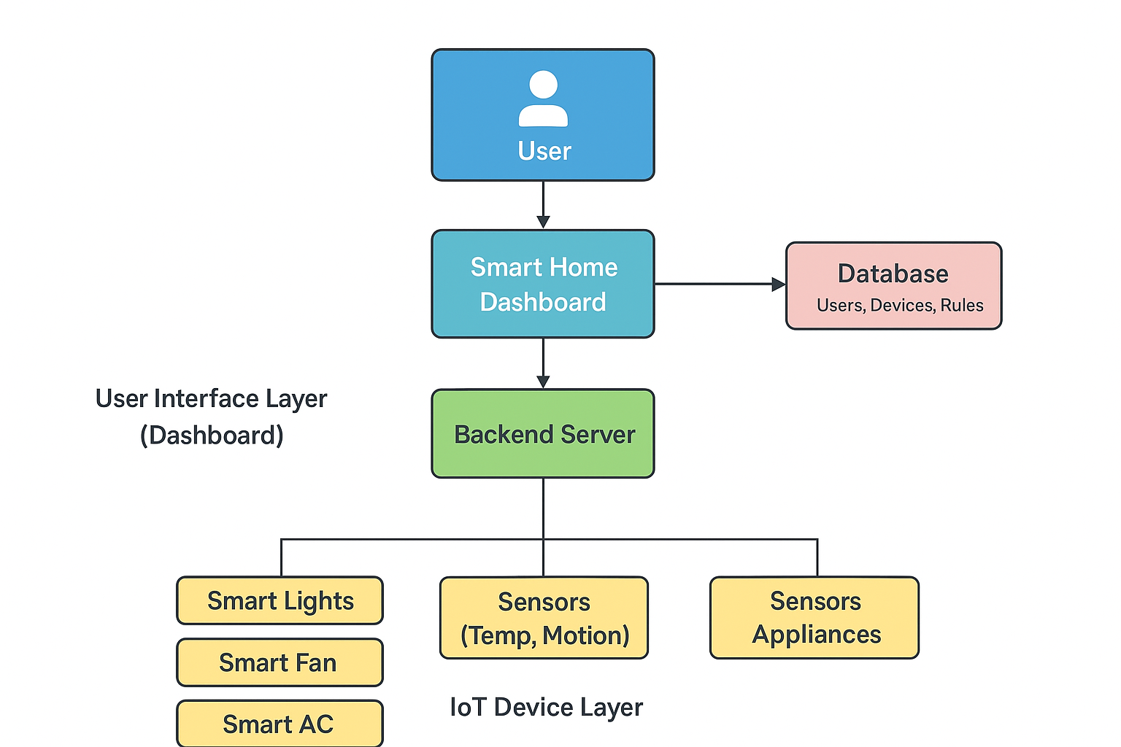

FIGURE 5.1 SMART HOME DASHBOARD SYSTEM ARCHITECTURE

The Unified Smart Home Control Dashboard. The user interacts with the system through the dashboard interface, which communicates with the backend server for processing commands and managing automation rules. The backend exchanges data with the database and controls IoT devices such as smart lights, fans, ACs, and sensors, enabling real-time monitoring and automation.

INITIALIZATION STEP
The system begins with the user logging into the dashboard using secure authentication. Once logged in, the backend retrieves user-specific devices, room configurations, and automation settings from the database.

LOCAL NODE COMPONENTS
Local node components consist of smart home hardware such as ESP8266/NodeMCU microcontrollers, sensors (temperature, humidity, motion), and relay modules connected to appliances. Each local node collects sensor readings, controls specific appliances, and communicates with the backend.

LOCAL DEVICE OPERATIONS
This layer includes the real-time operations performed by smart devices. Sensors gather environmental data continuously, while relay modules execute actions like turning lights, fans, or ACs ON/OFF. Local devices operate autonomously for basic functions but rely on backend commands for advanced automation.

COMMAND SENDING
When a user interacts with the dashboard by selecting ON/OFF actions or triggering automation, a command is sent to the backend server. The backend converts this request into MQTT/HTTP messages, which are forwarded to the respective IoT device. The device receives the command through its microcontroller and performs the required operation immediately.

AUTOMATION PROCESSING AT BACKEND
The backend contains a rule-based automation engine that processes conditions such as schedules, timers, temperature thresholds, and motion triggers. It evaluates real-time sensor data and decides whether an action should be performed automatically. For example, turning off lights when no motion is detected.

GLOBAL STATUS UPDATE
Once a device executes a command, it sends updated status information back to the backend. The backend stores this new state in the database and forwards the update to the dashboard. Users can instantly see the current condition of lights, fans, ACs, and sensors. This ensures that the dashboard always displays accurate real-time information.

.

DEVICE DATA DISTRIBUTION
After a device updates its status, the backend processes the data and distributes it to different system modules. The dashboard receives the updated values instantly for real-time display. The database stores the information for logs and future analysis. The automation engine also uses this data to trigger rule-based actions. This ensures all parts of the system stay synchronized and up-to-date.

ITERATIVE PROCESS

The entire cycle—monitoring, processing, updating, and controlling continues in an iterative loop. Devices keep sending data, users keep issuing commands, and the backend continuously processes new information. This loop forms the core of real-time smart home automation, providing continuous and uninterrupted service.

REAL-WORLD APPLICATION CONTEXT

The architecture can be applied in various real-world environments such as smart homes, apartments, offices, hostels, hospitals, and elderly care facilities. It supports energy management, security monitoring, automation scheduling, and remote access. The design is scalable, allowing multiple devices and rooms to be added without reconfiguring the system.

CHAPTER 6
SYSTEM REQUIREMENTS
  - HARDWARE REQUIREMENTS

- ESP8266 (NodeMCU) | : IOT microcontroller with wifi
- DHT22 Sensor | : Temperature and humidity measurement
- Relay Module | : Controls electrical appliances
- AC Bulb | : Load device for demonstration
- Power Adapter  - Breadboard/PCB | : 5V regulated power supply  : Hardware connections base

  - SOFTWARE REQUIREMENTS

- Component | : Technology
- Programming | : C/C++ (Arduino)
- Platform | : Blynk IoT Cloud
- IDE | : Arduino IDE
- Communication Protocol | : MQTT / HTTP
- OS | : Windows / Android

CHAPTER 7
SYSTEM IMPLEMENTATION
  - LIST OF MODULES

- User Authentication & Profile Management
- Appliance Control
- Energy Monitoring
- Dashboard & Visualization
- Notification & Alert
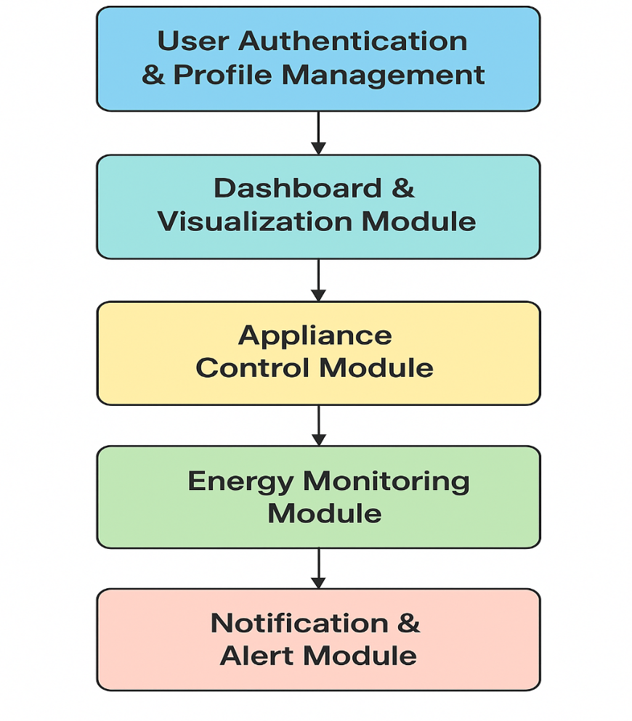

FIGURE 7.1.1 MODULE WORKFLOW

This image shows a detailed workflow of The user logs in and interacts with the dashboard, which sends commands to control appliances and display real-time sensor and energy data. The backend processes these operations, while the notification module alerts users about important events or abnormalities.

MODULES DESCRIPTION
    - USER AUTHENTICATION & PROFILE MANAGEMENT
This module ensures that only authorized users can access the smart home dashboard. It handles secure login, registration, password recovery, and user session management. When a user logs in, the system retrieves their personalized settings, such as room arrangement, preferred automation rules, connected devices, and theme preferences. The module uses encrypted storage to protect sensitive information and prevents unauthorized access through validation and role-based permissions. This enhances both security and user personalization within the smart home system.

DASHBOARD & VISUALIZATION
The dashboard serves as the central interface through which users interact with the smart home system. It provides a clean and intuitive layout that displays the status of appliances, real-time sensor readings, room-wise device grouping, and quick access controls. The visualization engine presents energy usage charts, automation activity, and alerts using graphical elements like gauges, graphs, and color-coded indicators. The module also refreshes device states in real time using WebSocket or MQTT connections, ensuring that users see the most accurate and updated system information at all times.

APPLIANCE CONTROL
This module manages all operations related to controlling home appliances such as lights, fans, and air conditioners. It receives user commands from the dashboard and converts them into executable signals for IoT devices using REST APIs or MQTT protocols. It ensures reliable delivery of commands and instantly reflects the updated device status on the interface. The module also supports advanced features such as grouping multiple devices, scheduling tasks, setting timers, and handling manual overrides. Its seamless communication between the server and hardware provides smooth and efficient smart home automation.

ENERGY MONITORING
The Energy Monitoring Module collects data from power sensors to track the energy consumption of appliances in real time. It processes electrical readings, calculates usage patterns, and identifies high-power devices that contribute to energy waste. This data is visualized through the dashboard to help users understand their consumption trends and optimize power usage. Additionally, the module supports threshold-based alerts, enabling the system to warn users when consumption exceeds expected levels. The collected data is stored long-term for analytics and reporting, promoting energy efficient living..

NOTIFICATION & ALERT
This module enhances the safety and responsiveness of the smart home system by generating alerts based on specific conditions. It monitors sensor inputs such as motion detection, sudden temperature rise, or unexpected device activity. When an event occurs, it sends notifications through the dashboard, email, or mobile push alerts, depending on the user’s preferences. The module also provides reminder notifications for scheduled tasks or automation triggers. It ensures that users are informed immediately about critical events, contributing to home security and proactive system monitoring.

DATASET DISCRIPTION
    - DEVICE STATE DATA
The device state dataset stores the ON/OFF status of all connected smart appliances such as lights, fans, and ACs. Each entry includes the device ID, device type, current state, and the exact timestamp of the recorded action. This information helps the dashboard display live device status to users. It is also essential for troubleshooting device issues and tracking daily usage behaviour.

SENSOR DATA (TEMPERATURE & MOTION)
This dataset contains continuous readings from temperature, humidity, and motion sensors placed throughout the home. Each sensor record includes sensor ID, sensor type, measured value, and timestamp. The data is used to update the dashboard in real time and support automation rules such as temperature-based AC control or motion-triggered lights. It helps ensure a responsive and intelligent smart home environment.

ENERGY USAGE
The energy usage dataset tracks the amount of electrical power consumed by each appliance over specific time intervals. It stores details like device ID, voltage, current, power consumption, and duration of use. These values help visualize energy patterns and identify high-consumption devices. The dataset supports energy-saving recommendations and long-term consumption analysis.

AUTOMATION LOG DATA
The records all automated actions executed by the system based on predefined rules. The logs include rule ID, device involved, trigger type (time, sensor, schedule), and the action performed. This helps users understand how automation behaves in different situations. It also assists in debugging and improving automated workflows by providing a structured history of events.

USER ACTIVITY LOGS
User activity logs store information about actions performed by users through the dashboard, such as switching devices ON/OFF or modifying automation settings. Each log captures user ID, action type, and timestamp. These logs assist in personalizing the dashboard experience and help administrators understand user behaviour. They also improve system reliability by tracking all manual operations.

SYSTEM NOTIFICATION
The dataset contains records of alerts generated by the smart home system, including notifications for motion detection, device faults, temperature spikes, or abnormal energy usage. Each alert is stored with an alert ID, message, device reference, and timestamp. This data ensures users are informed about important events and helps maintain safety and system awareness. It also supports audit trails for system monitoring.

ROOM ENVIRONMENT
This collects environmental readings from multiple room-based sensors such as temperature, humidity, light intensity, and air quality (if available). Each record includes room ID, sensor values, and timestamps. The system uses this combined data to optimize automation, such as adjusting lighting or activating AC. It enhances comfort and ensures accurate environmental monitoring across different areas of the home.

AUTOMATION RECOMMENDATION
The system generated suggestions for improving automation efficiency based on usage patterns. It includes fields such as recommendation ID, device ID, trigger type, suggested action, and reasoning. These insights help users create smarter automation routines, such as turning off unused devices or adjusting schedules. It supports future AI-based enhancements and user-driven energy optimization.

SECURITY & ACCESS LOG DATA
The system records all security-related activities such as login attempts, authentication failures, device access permissions, and unusual behaviour detected in the system. Each entry includes user ID, action type, IP address, time stamp, and security status. The dataset helps identify unauthorized access attempts and ensures accountability within the smart home environment. It also enhances system protection by supporting threat detection and audit trail analysis.

CHAPTER 8 SYSTEM TESTING
System testing is a critical phase that ensures the complete Smart Home Control Dashboard operates as expected in real-time conditions, integrates smoothly with IoT devices, and delivers accurate and secure data to the user. This chapter documents the various testing methods used to validate the system’s functionality, performance, reliability, security, and user experience. Each module such as authentication, device control, automation, dashboard UI, backend API, MQTT communication, and energy monitoring was tested individually and collectively to ensure seamless end-to-end operation

UNIT TESTING
In unit testing was performed for each functional component of the system. This included testing authentication functions, sensor data handlers, device command functions, automation triggers, and notification generators. Each unit of code was tested using both valid and invalid inputs to confirm correct error handling. For example, login functions were tested with incorrect passwords, empty fields, and unauthorized accounts. Device control functions were tested to ensure correct interpretation of ON/OFF commands and proper handling when devices were offline. Sensor data functions were tested to handle missing packets or corrupted readings. These unit tests helped in detecting minor bugs early and ensured each module worked independently before being integrated.

INTEGRATION TESTING
Integration testing ensured that multiple modules worked together without conflict. The dashboard UI was integrated with backend APIs, and the backend was linked with IoT devices using MQTT and REST protocols. The data packets transmitted between sensors and the server were monitored for consistency and reliability. It also verified that when a device state changed manually, the dashboard updated immediately. This testing phase confirmed that all modules communicated and synchronized effectively.

PERFORMANCE TESTING
Performance testing measured how well the system responded under various operational loads. The dashboard's responsiveness was evaluated with multiple devices connected simultaneously. Commands were sent rapidly to check if the system could handle burst operations without delay. Sensor data was simulated at high frequency to confirm the real-time graph updates remained smooth and stable. Stress tests were performed by connecting multiple virtual devices, sending continuous MQTT messages, and loading large historical energy datasets. The system showed strong performance, with low latency, fast page loading, and reliable real-time updates, indicating readiness for real household deployment.

SECURITY TESTING
Security testing focused on protecting user accounts, device access, and communication channels. Passwords were checked for secure storage and hashing. Brute-force login attempts were simulated to evaluate account lockout mechanisms. API endpoints were tested for unauthorized access by trying to trigger device actions without authentication. Communication between the dashboard, backend, and IoT devices was verified for secure transmission using protocols that prevent tampering. Input validation was performed to avoid SQL injection or malicious script attacks. The results confirmed that sensitive data was protected and unauthorized actions were prevented, reinforcing the system's security reliability.

USABILITY TESTING
Usability testing evaluated how easily users could operate the dashboard. Test users were asked to perform actions such as controlling appliances, adjusting automation rules, and observing energy charts. Their feedback helped refine UI elements such as button size, color indicators, device grouping layout, and menu navigation. User experience improvements included adding status colors (green for ON, red for OFF), tooltips for devices, simplified navigation buttons, and clearer icons. As a result, the system became more intuitive, visually appealing, and friendly for non-technical users, ensuring comfortable daily usage.

CHAPTER 9 RESULTS AND DISCUSSION
The implementation of the Unified Smart Home Dashboard demonstrated significant improvements in managing and controlling various smart devices through a single, cohesive interface. During testing, the dashboard successfully enabled real-time monitoring of devices such as lights, fans and security systems, allowing users to observe their operational status instantly and make adjustments remotely with minimal latency. Data collected from IoT sensors integrated into the system provided valuable insights into energy consumption patterns, device usage frequency, and operational efficiency. For instance, the system recorded periods of high energy usage and allowed automated scheduling of appliances, which resulted in noticeable energy savings during peak hours. Additionally, the backend integration and API communication protocols ensured smooth interaction between devices from different manufacturers, addressing common challenges of interoperability and device fragmentation. The system also incorporated alert mechanisms that notified users of unusual activities, such as abnormal energy spikes or security breaches, enhancing both convenience and safety. User feedback indicated that the unified dashboard interface was intuitive and streamlined, reducing the complexity typically associated with managing multiple smart home applications separately. Analysis of the data revealed trends that could inform predictive automation, such as preemptively turning off devices in unused rooms or adjusting climate control based on occupancy patterns. Furthermore, the scalability of the system was tested by adding additional devices, demonstrating that the dashboard could handle multiple simultaneous connections without degradation in performance. Overall, the results highlight the effectiveness of a centralized smart home control platform in optimizing energy efficiency, improving user experience, and providing a reliable and secure environment. These findings underscore the potential of such systems to evolve further with AI-based predictive features, voice or gesture control, and cloud analytics for long-term data-driven insights, positioning the unified dashboard as a cornerstone in the development of intelligent, energy-conscious, and user-friendly smart homes.

CHAPTER 10
CONCLUSION AND FUTURE ENHANCEMENTS

  - CONCLUSION
In conclusion, The development of the Unified Smart Home Dashboard has successfully demonstrated the potential of integrating diverse smart devices into a single, centralized platform that is both user-friendly and highly functional. Through the implementation of this system, users can efficiently monitor, control, and automate devices such as lighting, climate control, security systems, and household appliances in real time. The system’s ability to consolidate device management eliminates the need for multiple disparate applications, addressing one of the primary challenges in smart home environments—fragmentation and lack of interoperability. Performance evaluations indicated that the dashboard provided smooth communication between devices, rapid response to user inputs, and reliable alert mechanisms for abnormal events, including security threats or unexpected energy consumption spikes. Moreover, the data collected from IoT sensors allowed for meaningful analysis of energy usage and operational patterns, which can be leveraged for optimization and cost reduction. The project also highlighted the importance of a secure and robust backend system, ensuring data privacy and reliable connectivity across the network of devices. Overall, the Unified Smart Home Dashboard enhances user convenience, promotes energy efficiency, improves home security, and lays a strong foundation for future innovations in intelligent home automation, demonstrating a practical approach toward creating smart, interconnected, and adaptive residential environments.

FUTURE ENHANCEMENTS
Looking forward, the Unified Smart Home Dashboard can be significantly enhanced with advanced technologies and additional functionalities. One key area of improvement is the integration of Artificial Intelligence (AI) and Machine Learning (ML) algorithms to enable predictive automation and intelligent decision-making. For example, the system could automatically adjust lighting, heating, and appliance schedules based on learned user behavior and occupancy patterns, improving energy efficiency and comfort. Voice-activated control through integration with assistants like Amazon Alexa, Google Assistant, or custom voice recognition systems could provide a more natural and hands-free interaction with the dashboard. Gesture-based control and wearable device integration could further enhance touchless operation. On the security front, future versions could include real-time facial recognition, anomaly detection, automated emergency notifications, and integration with surveillance systems to provide a safer living environment. Expanding the system to support cloud-based analytics would allow for storage of historical data, long-term performance analysis, predictive maintenance, and insights into energy consumption trends, while also enabling federated learning models to improve AI predictions without compromising user privacy. Moreover, broader device compatibility and adherence to multiple IoT communication standards will ensure seamless integration of new devices, promoting scalability and future-proofing the system. Mobile application and wearable extensions can provide users with remote access, instant notifications, and real-time control from anywhere, enhancing convenience and accessibility. By incorporating these enhancements, the Unified Smart Home Dashboard can evolve into a fully intelligent, energy-conscious, and adaptive ecosystem capable of transforming the way users interact with their homes and achieve a higher level of automation, efficiency, and security.

APPENDIX 1 SOURCE CODE
#define BLYNK_TEMPLATE_ID "TMPL3wGRl0Y0c"
#define BLYNK_TEMPLATE_NAME "SMART HOME AUTOMATION"
#define BLYNK_AUTH_TOKEN "a5G_56TAc_IJuP_OHC_o-zPyyeEuAZTr"

#include <ESP8266WiFi.h>
#include <BlynkSimpleEsp8266.h>
#include <DHT.h>

#define DHTPIN D4
#define DHTTYPE DHT11
DHT dht(DHTPIN, DHTTYPE);

// Relay pins
#define RELAY1 D1
#define RELAY2 D2
#define RELAY3 D5
#define RELAY4 D6

char ssid[] = "iot";
char pass[] = "123456789";

BlynkTimer timer;

void sendSensorData() {
float t = dht.readTemperature();
float h = dht.readHumidity();

if (!isnan(t) && !isnan(h)) {
Blynk.virtualWrite(V0, t); // Temperature
Blynk.virtualWrite(V1, h); // Humidity
}
}

void setup() {
Serial.begin(115200);

pinMode(RELAY1, OUTPUT);
pinMode(RELAY2, OUTPUT);
pinMode(RELAY3, OUTPUT);
pinMode(RELAY4, OUTPUT);

digitalWrite(RELAY1, HIGH);
digitalWrite(RELAY2, HIGH);
digitalWrite(RELAY3, HIGH);
digitalWrite(RELAY4, HIGH);

Blynk.begin(BLYNK_AUTH_TOKEN, ssid, pass);
dht.begin();

timer.setInterval(5000L, sendSensorData);
}

void loop() {
Blynk.run();
timer.run();
}

// Relay controls from BLYNK buttons
BLYNK_WRITE(V11) { digitalWrite(RELAY1, param.asInt() ? LOW : HIGH); }
BLYNK_WRITE(V12) { digitalWrite(RELAY2, param.asInt() ? LOW : HIGH); }
BLYNK_WRITE(V13) { digitalWrite(RELAY3, param.asInt() ? LOW : HIGH); }
BLYNK_WRITE(V14) { digitalWrite(RELAY4, param.asInt() ? LOW : HIGH); }
APPENDIX 2 SCREENSHOTS
  - SMART HOME DASHBOARD

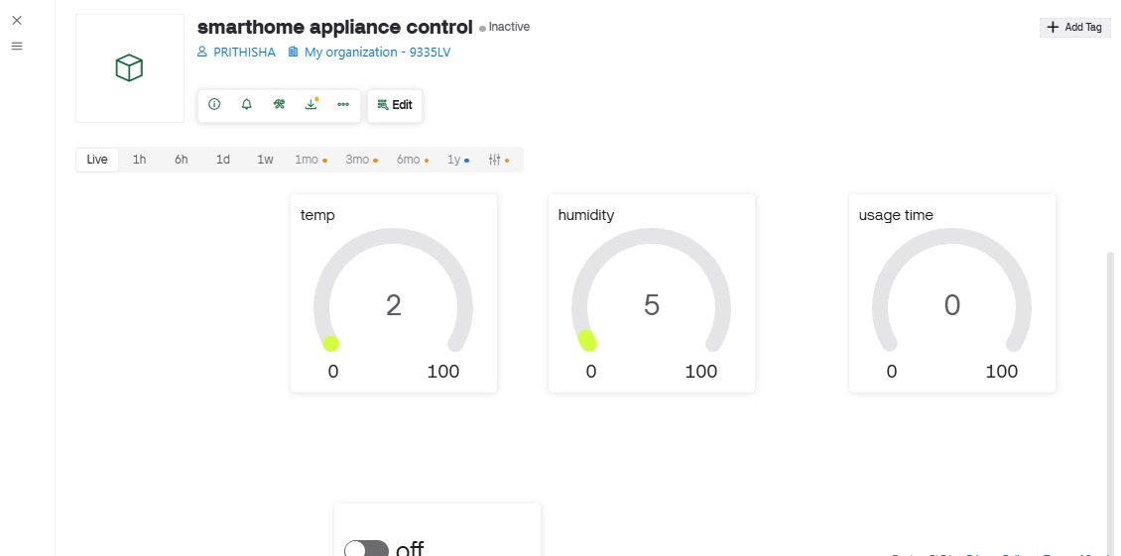

  - NOTIFICATIONS 7

- 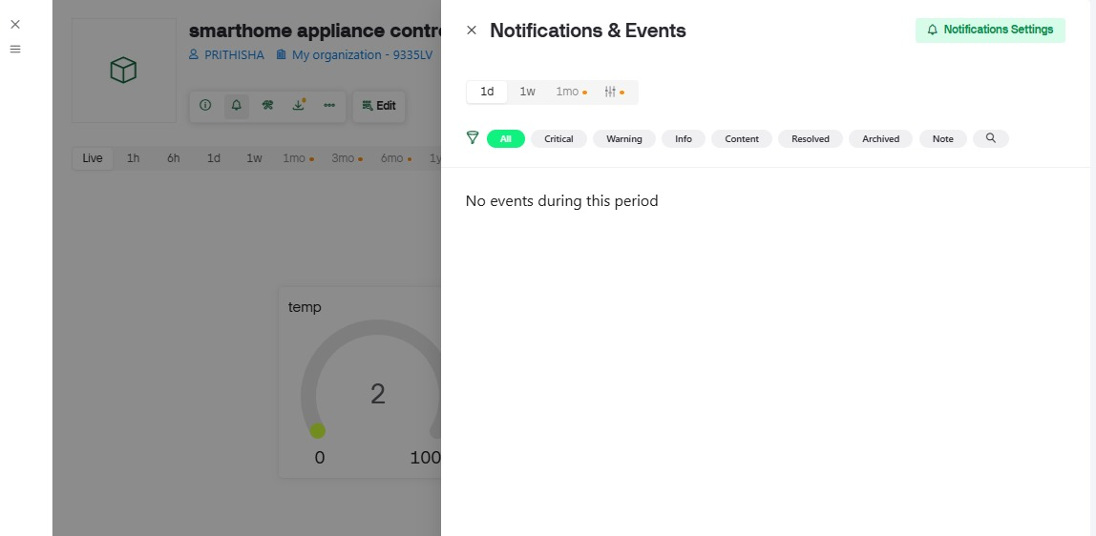

REFERENCES
- P. Kar and P. Ingkasit : Development of a User-Friendly and Efficient Control System for Smart Home-2024
- L. Xue, G.-P. Liu & W. Hu – All-in-One Framework for Design, Simulation, and Practical Implementation of Distributed Multiagent Control Systems – 2024
- J. Jerry Daniel, C. Byju, G. Rakesh & G. Lekshmi – Web-based Manhole Overflow Prediction System Using Ultrasonic Level Sensors and Expert System – 2022
- M. L. Shri, K. Santhi, A. Pandey, T. Aaglave & A. Pandey – Local Home Server for Device Automation & Control using IoT – 2025
- S. Manna & A. Banerjee – Experimental Study on MQTT Protocol Based Home Automation System with Enhancement – 2024
- A. Latifov & A. Pradeep – Design and Implementation of a LoRa-based Home Monitoring System with Heltec ESP32 Gateway – 2023
- I. G. M. N. Desnanjaya & I. M. A. Nugraha – Design and Control System of Sluice Gate With Web-Based Information – 2021
- M. Kumar, R. K. Gupta, G. Jain & P. Sharma – Next-Generation Smart Homes: An IoT Approach to Home Automation and User Experience – 2024
- A. Gozuoglu, O. Ozgonenel & C. Gezegin – Design and Implementation of Controller Boards to Monitor and Control Home Appliances for Future Smart Homes – 2024
- V. N. K. R. Devana et al. – IoT Based Home Monitoring and Appliance Control System – 2025

- M. Hamady, S. Alsaffar & L. Canale – AI-Driven User Interface for KNX-Based Home Automation Systems – 2025

- M. I. Abdullah, D. Roobashini & M. H. Alkawaz – Active Monitoring of Energy Utilization in Smart Home Appliances – 2021

- H. Wu – Design and Implementation of IoT-Based Smart Home System – 2024

- A. Fereidunian, Z. Alimoradi & M.-A. Sebt – Energy Smart Environments: Toward a Systems Perspective Framework for the Energy Dimension of Smart Systems – 2025

- S. K. R et al. – Efficient Energy Saving Techniques in Smart Homes through IoT – 2025

